Pig Launchers & Receivers
LINESIG Pig Launchers and Receivers are engineered as complete pipeline pigging stations for safe launching, receiving, isolation, depressurization and controlled handling of cleaning, batching and inspection pigs across oil, gas and refined-product pipelines. Heavy-duty pressure-retaining construction, quick-opening closure arrangements, drain and vent provisions, pig signal interfaces, isolation philosophy and project-specific materials allow each system to be configured for cross-country pipelines, terminals, refineries, marine facilities and transfer networks where reliable pigging operations and maintainable station layout are essential.
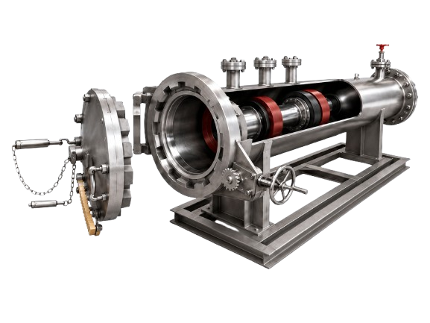
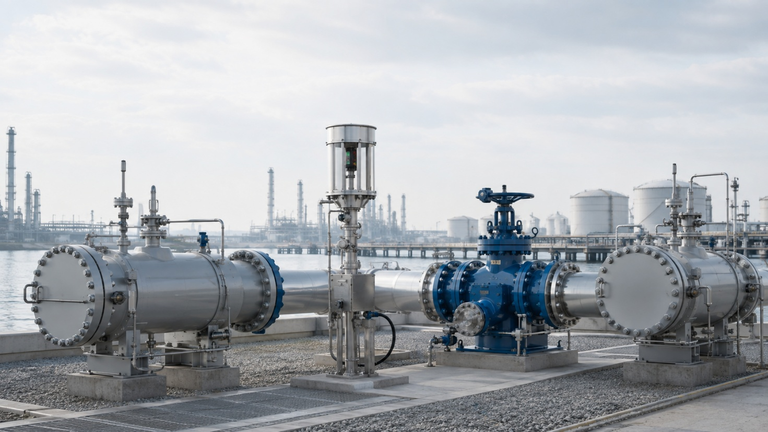

Bi-Directional Pig Signalers
LINESIG Bi-Directional Pig Signalers provide positive confirmation of pig passage in either pipeline direction and are available as Flag Type for local mechanical indication or Dual Type combining a mechanical flag with a digital electrical output for remote monitoring. Designed for installation on pig launchers, receivers and intermediate pipeline locations, the signalers support operator confirmation, PLC/SCADA event logging, sequence control and automated pigging functions while retaining a simple, robust field indication philosophy.
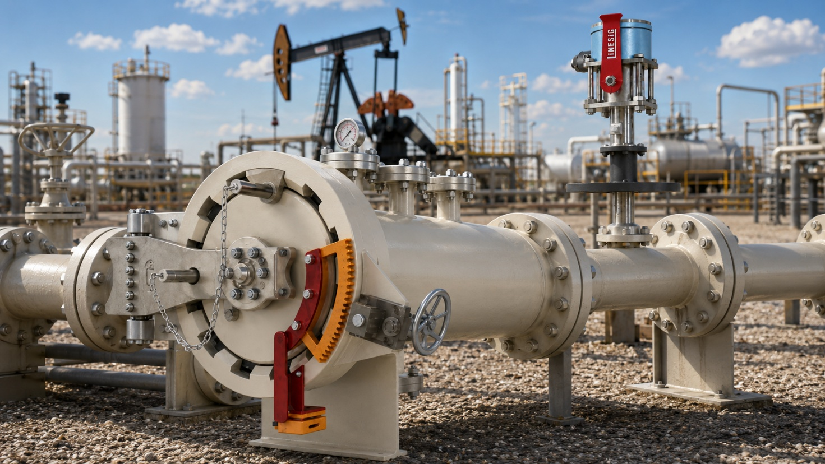

Pigging Valves
LINESIG Pigging Valves provide a compact multi-port solution for controlled routing of pipeline flow and pigs between selected pipeline branches, reducing the number of conventional valves, tees and manifold spools required in a traditional pigging station. Available in 2-way, 3-way and 4-way configurations with manual, electric, pneumatic or hydraulic operation, the LNS-WPV family is suited to oil, gas, fuel-terminal and process-pipeline applications requiring full-bore pig passage, positive directional control, reduced station footprint and integration with remote operating or automation systems.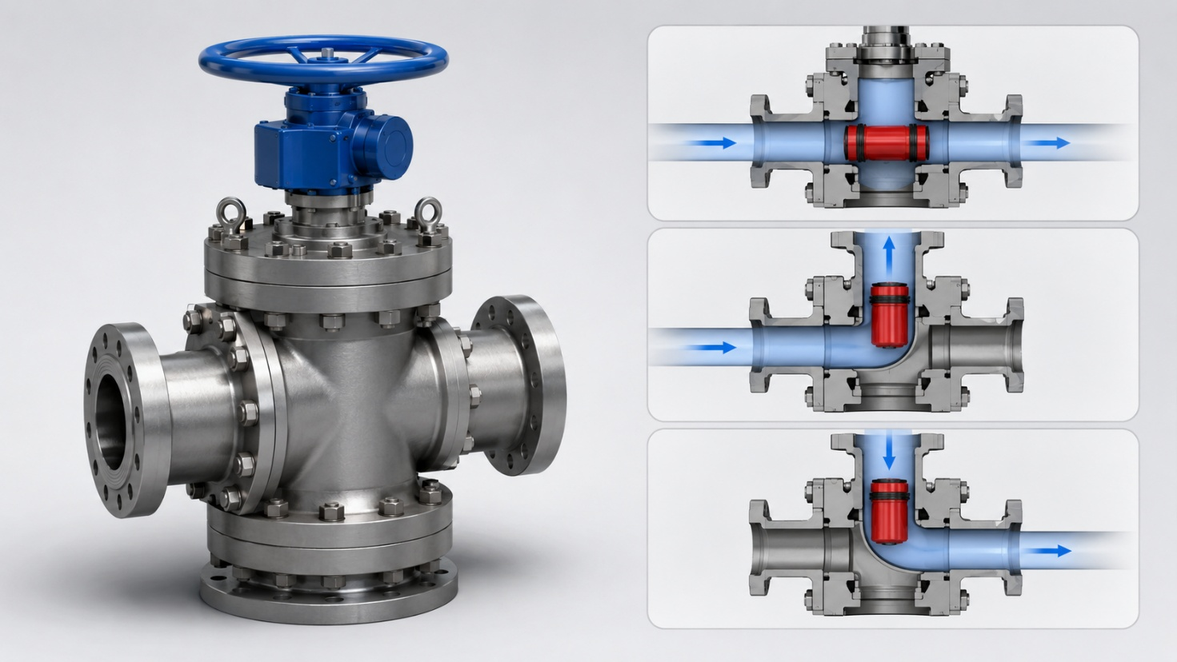
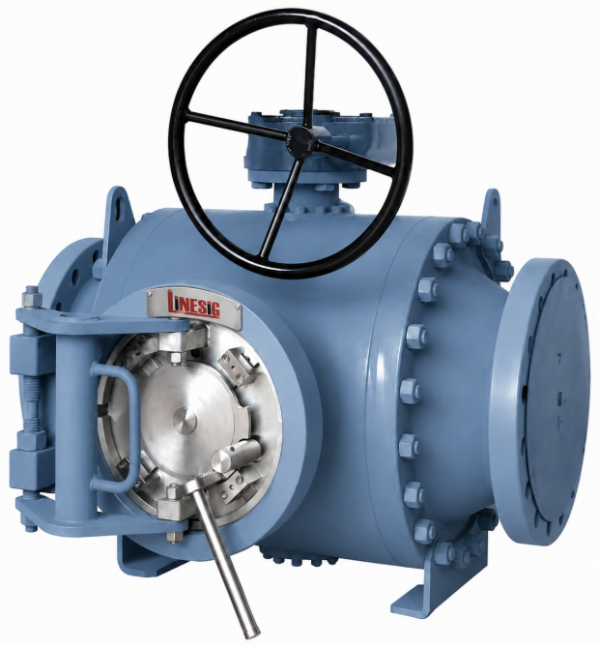

Metering Skids & Loading Racks
The LINESIG LNS-MS Series combines skid-mounted metering, flow conditioning, batch control, safety interlocks and terminal automation for tanker loading of liquid hydrocarbons, fuel oils/base oils, LPG and LNG. Coriolis mass flow measurement is preferred where technically applicable, with product-specific filtration, pressure and temperature monitoring, FCV/batch control, explosion-proof batch controllers, static grounding, overfill protection, ESD interfaces and loading-arm or hose connections; integrated loading-rack solutions can support multiple tanker bays, transaction control, TAS/PLC/SCADA communication and coordinated terminal dispatch operations.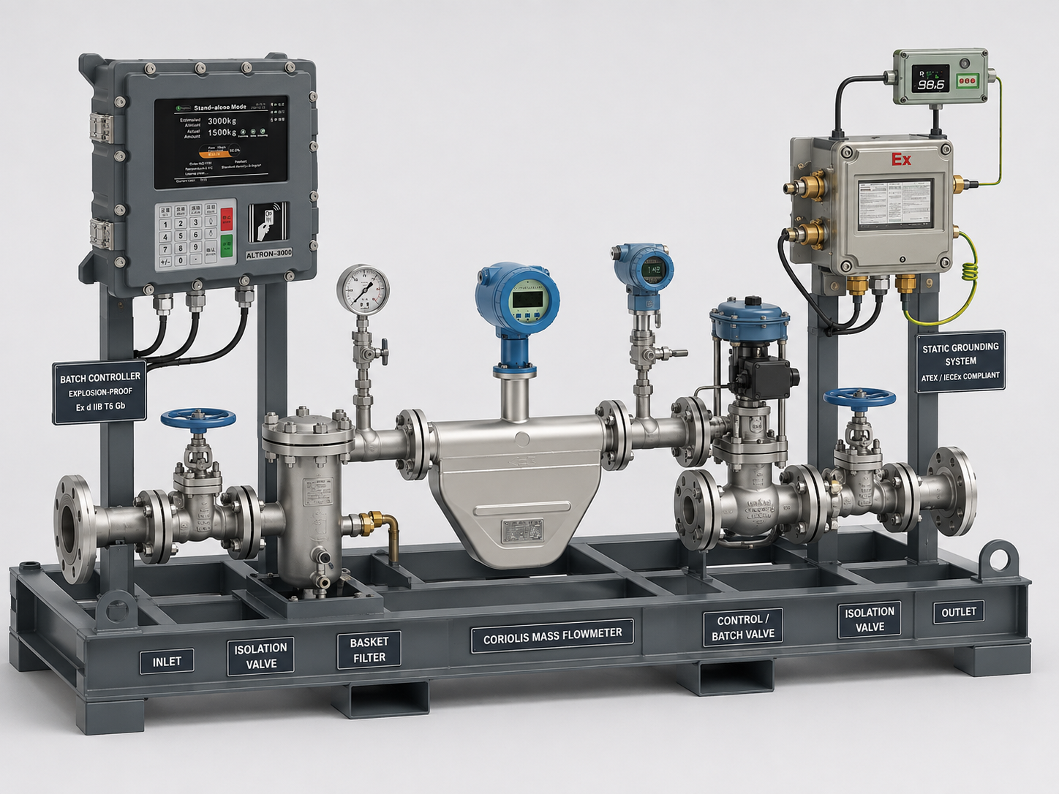
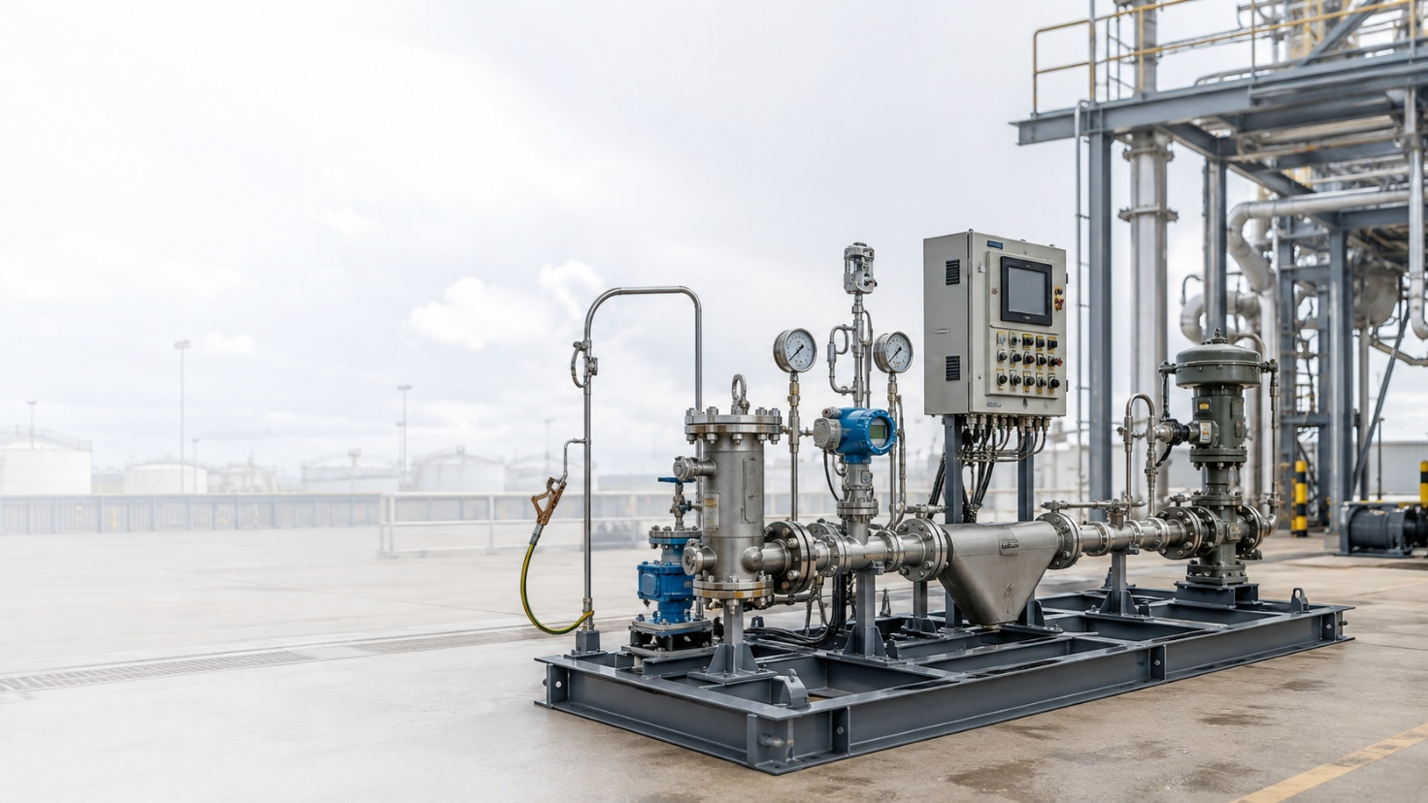

Multi-Channel Dosing Skids
LINESIG Multi-Channel Dosing Skids are modular additive and chemical injection systems designed to meter and inject multiple components accurately into a common process or loading stream. Each channel can be configured with dedicated metering, control, isolation, calibration and injection hardware, allowing the package to support fuel additives, dyes, performance improvers, blending components and process chemicals with recipe-based control, ratio management, batch synchronization and PLC/TAS integration for repeatable, traceable and automated dosing across terminal and process applications.
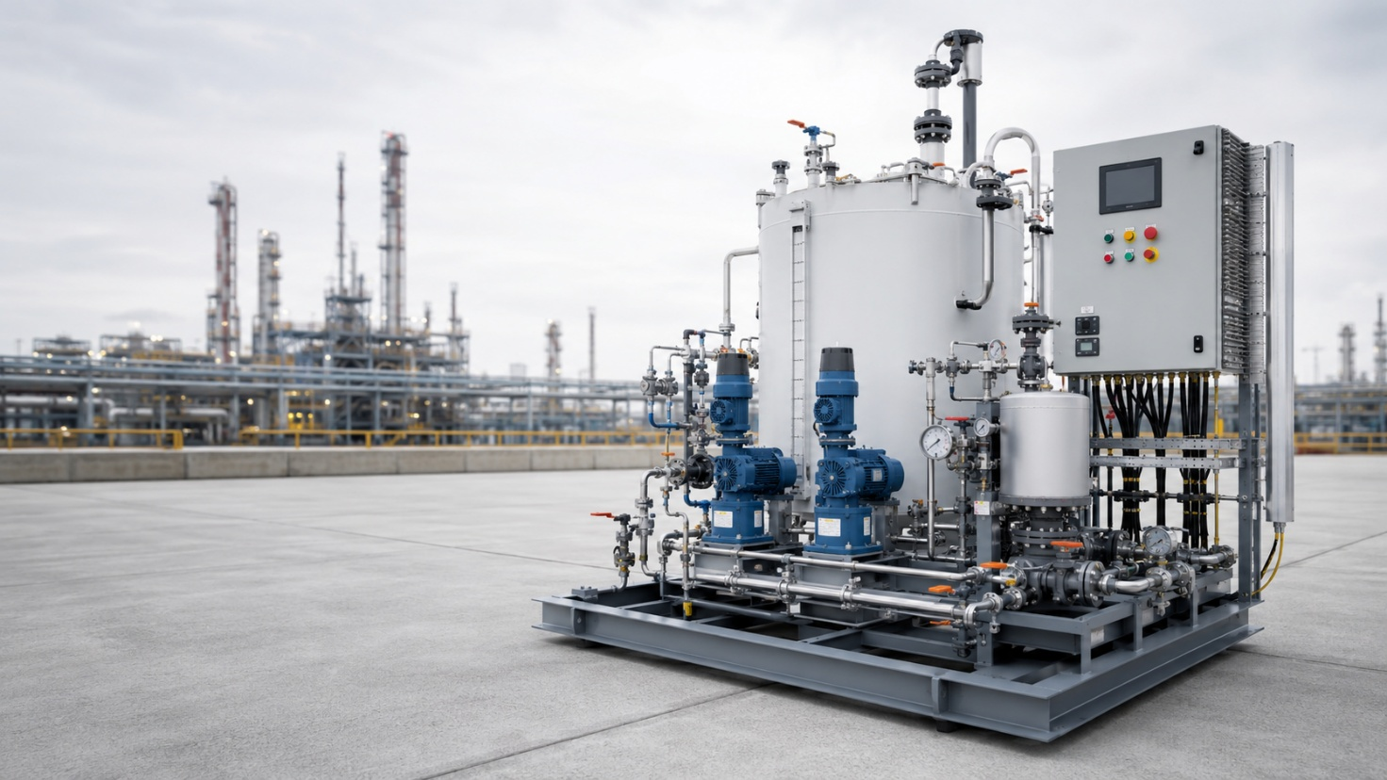

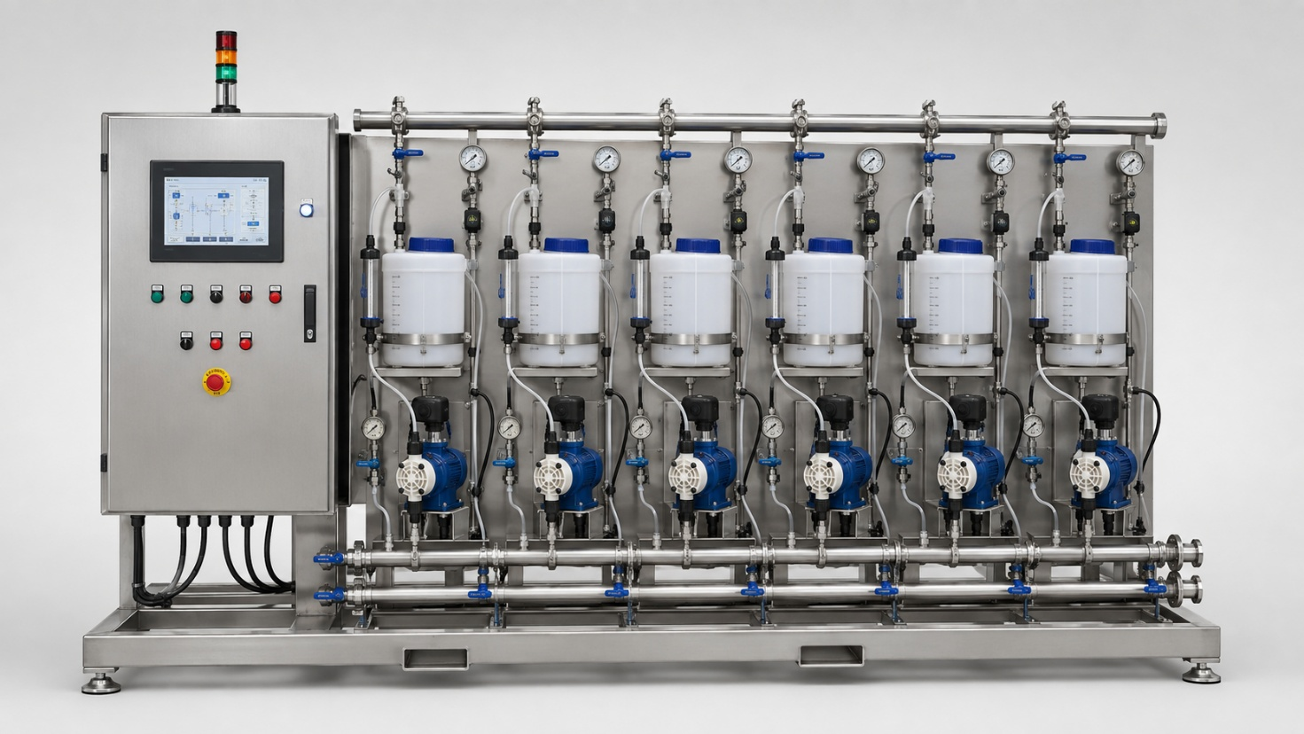

Scrubber Systems
LINESIG Scrubber Systems are engineered process packages for removal of liquid droplets, entrained contaminants, aerosols or undesirable components from gas and vapour streams before downstream treatment, compression, venting or recovery. Configurations may incorporate vertical or horizontal separation vessels, demisting elements, level control, drains, pressure instrumentation, pumps, control valves and package automation, with design tailored to the actual gas composition, flow range, pressure, temperature and required separation performance in refinery, terminal, petrochemical and hydrocarbon-handling services.
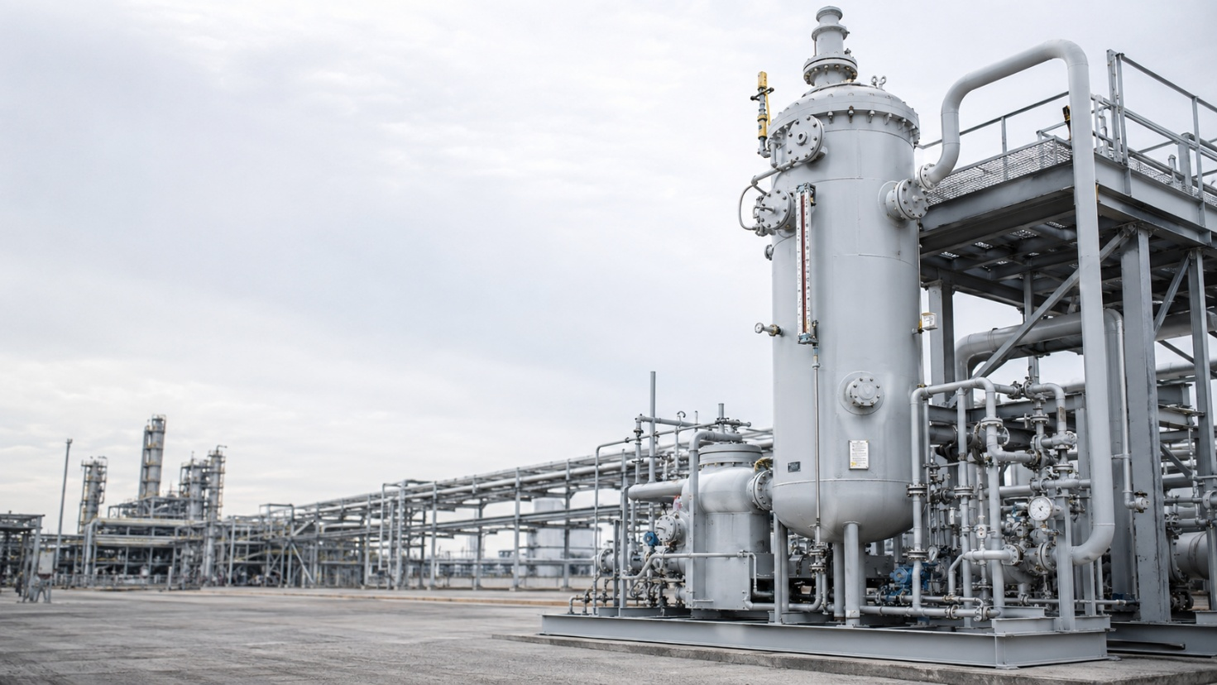

Vapour Recovery Units – VRU
LINESIG Vapour Recovery Units are designed to collect and recover hydrocarbon vapours generated during tanker loading and terminal operations, reducing atmospheric emissions while improving product recovery and loading safety. For multi-tanker gantry systems, vapour from individual loading bays is routed through a common vapour-return header to a centralized recovery package incorporating separation, vapour conditioning, recovery equipment, instrumentation and control, allowing the VRU to operate as an integrated part of the loading rack with batch, ESD and terminal automation interfaces for efficient, controlled and environmentally responsible terminal operation.
